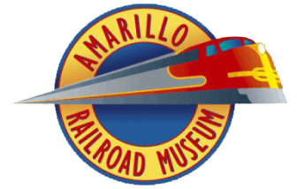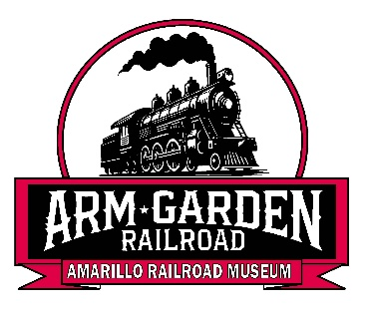**Amarillo Railroad Museum’s**

**Garden Railroad**

**P.O. Box 20172**

**Amarillo, Texas 79114**

**Email: jkru10a@gmail.com**

**Announcing the New A.R.M. Garden Railroad Club!**

**All Aboard!** If you love trains, history, craftsmanship, and creativity, our **Garden Railroading Club** is the perfect place for you! Whether you're an experienced modeler or just getting started, we welcome all enthusiasts to share their passion for trains.

Join the **Amarillo Railroad Museum** and local G-Scale model railroad enthusiasts in building the **A.R.M. Garden Railroad**! Experience the thrill of running trains on scenic outdoor tracks, connect with fellow hobbyists, and help create a unique public destination celebrating the art and history of garden railroading. All aboard for fun!

**Why Join Us?**

✅ **Run & Operate Trains** – Enjoy realistic model train operations on a new layout with G-scale (45mm) track, for 1:20.3, 1:24, 1:29 scale locomotives and rolling stock.  
✅ **Learn & Share Skills** – From layout design and construction to scenery building, there's always something new to explore!  
✅ **Meet Fellow Enthusiasts** – Connect with people who share your passion for railroads and model building.  
✅ **Club Events & Exhibits** – Participate in train shows, public displays, and workshops.  
✅ **Historical & Technical Insight** – Discover the history of railroads and enhance your modeling techniques.

✅ **Access to the Amarillo Railroad Museum Facilities:**

* Discover their impressive HO scale layout……
* Explore the “White Train”….
* and an opportunity to join their club for full use access.

**Who Can Join?**

🔹 Hobbyists of all skill levels  
🔹 Families and kids interested in trains  
🔹 Collectors and railroad history buffs

**How Do You Join?**

🔹 Membership Applications Available

🔹 Go To (simple web site with contact information and membership Application)

**Come aboard and bring your love of model trains to life!**